**Lombok Documentation**

Lombok is an open source library (standalone jar) which is mainly used to avoid boiler plate coding in Java, especially in POJO & Entity classes.

With the help of Lombok annotations such as **@Setter @Getter**, all the setters & getters generated codes can be removed.

**Example:**

**public** **class** LombokExample {

**private** String empName;

**private** String empId;

**public** String getEmpName() {

**return** empName;

}

**public** **void** setEmpName(String empName) {

**this**.empName = empName;

}

**public** String getEmpId() {

**return** empId;

}

**public** **void** setEmpId(String empId) {

**this**.empId = empId;

}

}

In the above example, for the variables empName & empId – to have setters & getters, approximately 12 lines of code is needed. These 12 lines of boiler plate codes can be removed & will be handled by Lombok.

**Using Lombok:**

@Getter

@Setter

**public** **class** LombokExample {

**private** String empName;

**private** String empId;

}

Using Lombok, we have removed all the setters & getters.

Lombok is not limited only to setters & getters. It can also be used to remove many boiler plate codes such as

* @NonNull
* @EqualsAndHashCode
* @ToString
* @NoArgsConstructor
* @RequiredArgsConstructor

**How to add Lombok to Java Projects:**

Lombok is available in Maven Repository & can be added in pom.xml as a maven dependency.

<dependency>

    <groupId>org.projectlombok</groupId>

    <artifactId>lombok</artifactId>

    <version>1.16.18</version>

</dependency>

**How to use Lombok in Eclipse:**

Though Lombok will work if we put Lombok on the project classpath. But to make it work with eclipse, we need to first do couple of steps to install it in eclipse.

* Download Lombok jar from Lombok or from Maven Repository

<https://projectlombok.org/downloads/lombok.jar>

* Go to downloaded Lombok Jar location. Either double click on the jar or execute the below command in cmd

java -jar lombok-1.16.18.jar

* On performing the above, a pop up of Lombok will Open & it will scan for Eclipse IDE location.

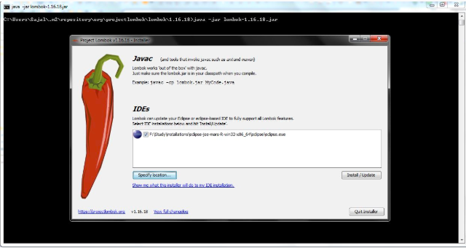

* Click on Install/Update button to install Lombok in Eclipse. This will install Lombok in Eclipse IDE and will show a Success Pop up.

